EVA CAFE



Title page

EVA CAFÉ
Address:- Addis Ababa, Nifas silk– Lafto

Name of the Owners Address
- Ayele Tegegnework…
- Geta Baweke
- Addis Gerlu
- Legesse Mekuriaw
- Biniam Admasu
- Beamlak Asteway …

Date of preparation: - January/20/202

Table of content

3) Executive Summery
EVA café is a 200-care meter café that will be located in Addis Ababa Nifas silk– Lafto around Karl square area.
The name EVA is a name originated from Hebrew and it means “life”. The EVA is the alternative to fast-food/commercial /coffee shops and offers a much calm life style, civilized café experience. There are no televisions in the café, and work from local artists will hang on the walls. The café is well appointed with bamboo chairs and tables with likely setting.
The EVA measures its financial success in terms of increased market share and in earnings. The keys to success will be the ability to offer quality gourmet coffees, pastries and juice.

Business concept/ Descriptions
The EVA Café’s primary offering is gourmet coffee and fresh fast foods like pastry, cake, etc. Complementing the coffee will be a smoothie line including wild berry, strawberry, peach, mango and lemonade. Rounding out the simple menu line will be pastries which is prepared in the café, freshly made and delivered to patrons. The pastry offerings may vary with seasonality but the primary line will muffins, breads, cookies, scones, and rolls.
  - Mission Statement
The EVA is committed to its products and employees which they believe is the key for market success.

Vision
The EVA is committed to values such as excellence, passion, quality, integrity and leadership which allow them to navigate challenges and provide for future opportunities. These core beliefs start with their commitment to their products and their employees. The EVA rewards excellence and cherishes loyalty. The café will work with its employees to build strong businesses and to be a brand café in Ethiopian café industry within 10years.

Business Objectives and goals

The primary objectives and goal of the business plan for EVA Cafe are below:
    - To maximize owner’s wealth
    - Achieve a profit margin of 10% in year 1, 12% in year 2, and 13% in year3
    - Be the café of choice in the “ADDIS ABABA NEFAS SELK- LAFTO “area (short term)
    - Be brand name in Ethiopian café industry ( in the long run)

Business philosophy
- Great Products – providing great products at market prices – will make customers want to return again and again
- Hire Quality Baristas – Pay employees rates similar to the larger chains with opportunities for long term careers and opportunities for advancement with long term plans to open a second facility.

  - target market
to whom will you in business?
  - describe your industry
  - company strength
  - Legal form of ownership

Ownership and legal form
The EVA will be owned by 6partners who are listed in the following table:
No | Full Name | Experience | Address |  | Contribution
No | Full Name | Experience | City | Phone number | Contribution
1 | Ayele Tegegnework | General Manager | A.Ababa | 0912780103 | 35,000
2 | Geta Baweke | Administration | A.Ababa | 0937655880 | 35,000
3 | Adisu Gedlu | Purchasing Manager | A.Ababa | 090456771 | 35,000
4 | Legese Mekuriaw | Office Manager | A.Ababa | 0985629436 | 35,000
5 | Biniam Admasu | Head chef | A.Ababa | 0986947407 | 35,000
6 | Beamlak Asteway | Sales manager | A.Ababa | 0920474660 | 35,000

Legal Form
The EVA will be formed as a partnership company wholly owned by 6 partners.

Service
5.1
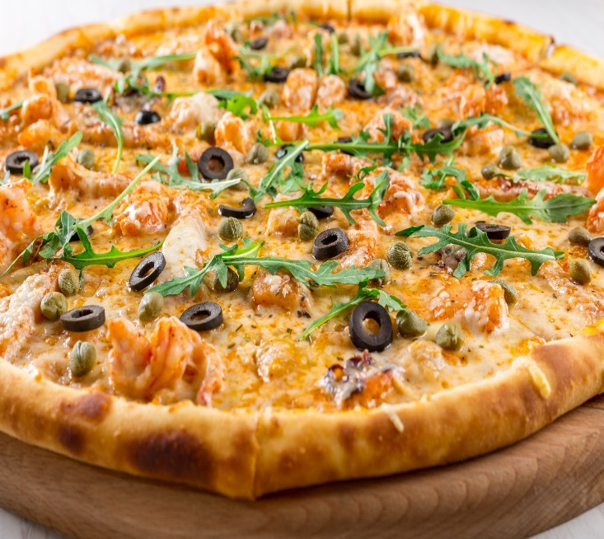
This Photo by Unknown Author is licensed under CC BY-NC

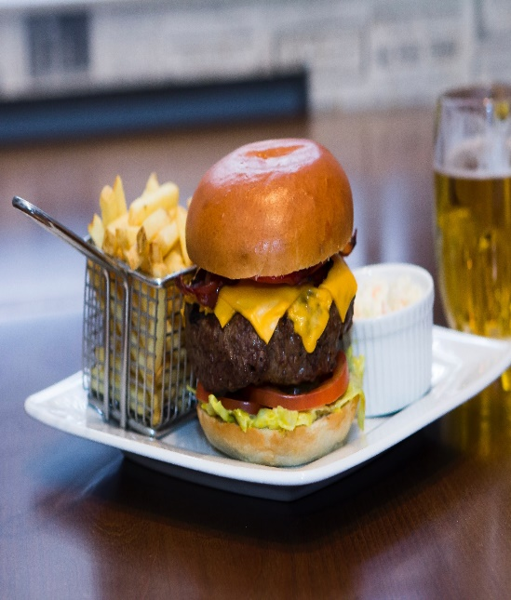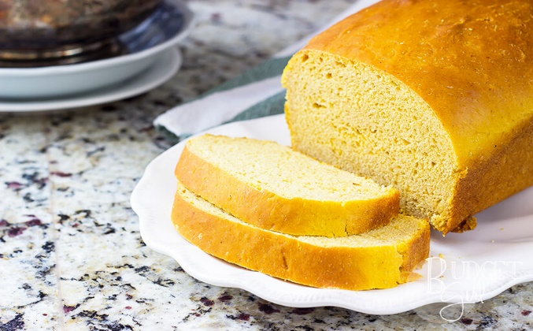
This Photo by Unknown Author is licensed under CC BY-NC

This Photo by Unknown Author is licensed under CC BY-SA-NC
5.2 quality and availability of input

The EVA Café has negotiated supplier agreements with several local food-service wholesalers and coffee wholesalers in Addis Ababa that have a reputation for quality and reliability:
    - Tomoca Coffee Roasters and Alem Bunna
    - Golden Bread
    - Lager Fruit (merkato)
    - Selam flour factory

5.3 how it works

✿Its work by using diffrent metodologies our company follow consumer orented method.
5.4 competitive advantage
✿providing good products than our competitors by using fair price and quality oriented.
5.5 pricing method
.
5.6 patent, trademark, and copyright issues
5.7 potential substitute

6. market research
6.1 potential customers
The EVA is targeting the three top segments of the population representing some of the population in the Karl square area:
- Boom burbs– Younger families with a busy, upscale lifestyle. Median age of 34. Most households operate on two incomes; median household income in Product purchases reflect a sub urban lifestyle.
- Enterprising Professionals– Young, highly educated, working professionals. Single or recently married, median age of 32. Lifestyle reflects youth, mobility, and growing consumer . Residents go where the jobs are located. Love to travel and exercise; rely heavily on cell phones, PCs and the internet to stay connected.
- Prosperous Empty Nesters – Well educated and experienced, residents are enjoying the transition from child rearing to retirement. Median age is 46. This market segment is active physically and financially. Display interest in homes/communities.

6.2 future market trends, window of opportunity
nity
♥Healthy food alternatives. ...
♥More comfortable seating arrangements. ...
♥More affordable menu additions. ...
♥Improved sanitary standards. ...
♥Better membership rewards programs.

  - Analyze competitors

Main Competitors
The research methodology is based on unique coffee shops/cafes in Addis Ababa Nifas Selk Lafto Karl Square area. which are:
- Babi’s bistro
- Pizza hut
- Amrogn chicken
- Kaldis coffee
- Bilo’s pastry
  - Niche
  - Project market share
  - Pricing and promotion strategy

Promotion and advertising strategy
      - Online Advertising - The EVA will advertise regularly on popular social media sites, such as Facebook ,Insatagram , Tiktok . Compared to traditional print advertising, this is a cost effective tactic that will allow them to reach prospects in a highly targeted way (e.g., based on criteria such as age, gender, geography, etc.).
      - Blog- the Russet Cup will develop a simple Web site, which will provide basic information about the business, the menu, and links to their presence on the aforementioned social media channels.
Radio Advertising (FM) - During the first six months of operation, and during the busy holiday shopping season, the business will advertise on local

Pricing strategy
The EAV primarily utilizes competition-based pricing. The café does not utilize coupons and discounts (other than opening promotion) because we believe that the most valuable customer demographic of daily café consumers is not influenced by discount programs or coupons

- marketing plan
elements of marketing plan

service

EVA tries to innovate its product mix to capture more of the market. This component of the marketing mix focuses on what the business offers to customers. The following are the main categories of EVA cafe products

1.Foods
        - Burger
        - Bites
        - Big Bites/Sandwiches
        - Cake
        - Cake Away
      - Beverages
        - Soup
        - Hot coffee
        - Cold coffee
        - International coffee
        - Hot tea
        - Cold tea
        - Frost teas
        - Fruity freezers
        - Lemonades
        - Soft drink
- Pricing system
The sales forecast assumes a conservative 18% increase in revenues during Year Two and 19% increase in Year Three. The following chart shows estimated sales over the next three years.

EVA café
sales budget
For the next three years ending December 31,2019
Product | unit price average | Quantity |  |  | Total revenue
 |  | year1 | year2 | year3 | year1 | year2 | year3
coffee, tea, etc | 13 | 25,000 | 30000 | 38000 | 325000 | 390000 | 494000
pastry, cake, etc | 18 | 40,000 | 50000 | 62000 | 720000 | 900000 | 1116000
soft drink | 10 | 20,000 | 23000 | 28000 | 200000 | 230000 | 280000
Juice | 25 | 10,000 | 13,000 | 15,000 | 250000 | 325000 | 375000
Total Revenue | 66 | 95,000 | 116000 | 143000 | 1495000 | 1845000 | 2265000
cost of sales | Cost per unit average
coffee, tea, etc | 4 | 25,000 | 30000 | 38000 | 100000 | 120000 | 152000

pastry, cake, etc | 7.5 | 40,000 | 50000 | 62000 | 300000 | 375000 | 465000
soft drink | 6 | 20,000 | 23000 | 28000 | 120000 | 138000 | 168000
Juice | 12 | 10,000 | 13,000 | 15,000 | 120000 | 156000 | 180000
Cost of goods sold | 29.5 | 95,000 | 116000 | 143000 | 640000 | 789000 | 965000
Gross margin |  |  |  |  | 855000 | 1056000 | 1300000

promotion
- distribution
- services and warranties
- marketing leadership

- operational plan
- production
The EVA Café’s primary offering is gourmet coffee and fresh fast foods like pastry, cake, etc. Complementing the coffee will be a smoothie line including wild berry, strawberry, peach, mango and lemonade. Rounding out the simple menu line will be pastries which is prepared in the café, freshly made and delivered to patrons. The pastry offerings may vary with seasonality but the primary line will muffins, breads, cookies, scones, and rolls.

- location
The EVA Café is located in the highly desirable area of Nefas Selk –Lafto,Addis Ababa in the Ethiobetoch building. The property is located in an excellent location. The property is leased with Price of birr 15,000 per month.

- Legal environment

Competitive Landscape
Consumer taste and personal income drive demand. The profitability of individual companies depends on the ability to secure prime locations, drive store traffic, and deliver high-quality products. Large companies have advantages in purchasing, finance, and marketing. Small companies can compete effectively by offering specialized products, serving a local market, or providing superior customer service. Specialty eateries, which cafés, are labor-intensive: average annual revenue per worker is about birr 24,000. Cafés compete with businesses such as convenience stores, gas stations, quick service and fast food restaurants, gourmet food shops, and donut shops
- Personnel
Initially the café will hire 1 manager, 8 department managers ,2 baristas, and 5 full time Waiters. In Year 2 and year 3, the café plans to hire 1 additional full time barista and 2 waiters and 1 additional full time barista and 4 waiters respectively.

PERSONELPLAN
Position | Annual Salary
Position | year1 | year2 | year3
General manager | 28,000 | 35,000 | 42,000
Administration Manager | 26,000 | 31,000 | 36,000
Purchasing manager | 26,000 | 31,000 | 36,000
0ffice manager | 26,000 | 31,000 | 36,000
Café manager | 26,000 | 31,000 | 36,000
Sales manager | 26000 | 31000 | 36000
Marketing Manager | 26,000 | 31,000 | 36,000
Financial Manager | 26,000 | 31,000 | 36,000
Baristas | 20,000 | 24,000 | 30,000
Baristas | 20,000 | 24,000 | 30,000
Baristas | 20,000 | 20,000 | 24,000
Baristas | 20,000 | 20,000 | 20,000
full time Waiters | 12,000 | 14,000 | 16,500
full time Waiters | 12,000 | 14,000 | 16,500
full time Waiters | 12,000 | 14,000 | 16,500
full time Waiters | 12,000 | 14,000 | 16,500
full time Waiters | 12,000 | 14,000 | 16,500
full time Waiters | 12,000  1 | 14,000 | 16,500
full time Waiters | 12,000 | 14,000 | 16,500
full time Waiters | 12,000 | 14,000 | 16,500
full time Waiters | 12,000 | 14,000 | 16,500
Total annual salary Expense | 310,000 | 418,000 | 546,500

- Inventory
- Suppliers

- management team

10. financial

rejected Profit And Loss
The estimated profit and loss for the EVA are as follows:

NOVA Café
Pro formal Income Statement
year1 year2 year3
Income
Total Income | 1495000 | 1845000 | 2265000
Total Cost of Goods Sold | 640000 | 789000 | 965000
Gross Margin | 855000 | 1056000 | 1300000
Expenses
Total Salaries and wages | 310,000 | 418,000 | 546,500
Business Expenses
Advertising | 10,000 | 10,000 | 10,000
Fright Expense | 10,000 | 13,000 | 15,000
Legal And Accounting | 5,000 | 10,000 | 10,000
Rent Expenses | 180,000 | 180,000 | 180,000
Repairs | 5,000 | 8,000 | 11,000
Supplies | 5,000 | 6,000 | 7,200
Telephone | 5,000 | 5,000 | 5,000
Utilities | 10,000 | 10,000 | 10,000
Miscellaneous Expenses | 3,000 | 3,000 | 3,000
Depreciation | 47,200 | 47,200 | 47,200
Total Business Expenses | 280,200 | 292,200 | 298,400
Total interest expenses | 12,000 | 0 | 0
Net Operating Income | 252,800 | 345,800 | 455,100
Less income Taxes | 88480 | 121030 | 159285
Net Profit (Loss) | 164,320 | 224,770 | 295,815

11)critical risks
The business area is one of the focus areas for both newly established and existing businesses this may cause for the birth of new and strong competitors of EVA café.
12) exit strategy
13) appendix

Stage Of The Business
Stage I:Existene Stage II: Survival Stage III: Success Stage IV: Takeo
Stage V: Resource Maturity
When we come to our business EVA café is categorized at the first stage. In this stage the main problems of the business are obtaining customers and delivering the product or service contracted for. Among the key questions are the following:

- Can we get enough customers, deliver our products, and provide services well enough to become a viable business?
- Can we expand from that one key customer or pilot production process to a much broader sales base?
- Do we have enough money to cover the considerable cash demands of this start-up phase?
So to answer such like questions and to facilitate our business operation we prepare this business plan. In this stage the organization is a simple one—the owner does everything and directly supervises subordinates, who should be of at least average competence. The company’s strategy is simply to remain alive. The owner is the business, performs all the important tasks, and is the major supplier of energy, direction, and, with relatives and friends, capital.

Start-Up Summary (Machine And Tool Requirements)
The EVA will have seating for 60 patrons/customers. The rent is Birr15 ,000 a month, with a three-five-year lease available. The site consists of 200 care meter of leased space consisting of a dining room, two restrooms, and back. The storefront needs painting, new floors, and countertops are also needed. A custom coffee bar needs to be built. With materials bought on sale, the cost to renovate will be birr 25,000. The cafe equipment will
Consist of one commercial espresso machine, a commercial blender, pastry case, microwave oven, toaster, upright refrigerator 2 door, upright freezer 1 door, compartment sink, storage racks/shelves/prep table, cup dispensers, water purification machine, ice holding bin and small wares. The cost for the equipment above is Birr 155,000. The furniture will consist of bamboo table and chairs which costs Birr 75,000. The artwork will be bought from local artists. Other startup expenses will be dishes, rent deposit, and marketing.

INDUSTRY ANALYSIS AND MARKETANALYSIS

Overall Market
The Ethiopian café industry includes many stores with combined great amount of annual revenue. Major companies include Kaldis coffee, Tomoka coffee, Alem Bunna, and etc. cafes are part of the specialty eatery industry, which also includes retail outlets specializing in products such as bagels, donuts, frozen yogurt, and ice cream.
.

3. DEVELOPMENT AND PRODUCTION

3.1. Stages for New Product Development
  - Idea generation

  - Idea screening

  - Concept development and testing

  - Product development

  - Test marketing

  - Commercialization

3.2. Production Process

3.2.1. Machine and Tool Requirements
EQUIPMENTREQUIREMENT
MACHINE/TOOL | PRICE PER UNIT | QUANTITY | TOTAL
ESPRESSO MACHINE | 20,000 | 1 | 20,000
ESPRESSO GRINDER | 8,000 | 1 | 8,000
PASTRY CASE, | 10,000 | 1 | 10,000
MICROWAVE OVEN | 15,000 | 2 | 30,000
TOASTER | 2,000 | 2 | 4,000
UPRIGHT REFRIGERATOR 2 DOOR | 30,000 | 1 | 30,000
UPRIGHT FREEZER 1 DOOR | 12,000 | 1 | 12,000
COMPARTMENT SINK | 2,000 | 3 | 6,000
STORAGE RACKS/SHELVES/PREP TABLE | 2,500 | 2 | 5,000
CUP DISPENSERS | 4,000 | 1 | 4,000
WATER PURIFICATION MACHINE | 10,000 | 1 | 10,000
ICE HOLDING BIN | 2,000 | 1 | 2,000
BAMBOO TABLE WITH 4CHAIRS | 5,000 | 15 | 75,000
SMALL WARES/MATERIALS | 40(AVERAGE) | 350 UPTO 500 | 20,000
TOTAL |  | 366 | 236,000

3.4. Quality assurance mechanism
- Train Staff

- Lead by Example

- Practice Proper Receiving and Food Storage

- Hire/Assign a Quality Assurance Manager

4. MARKETING PLAN AND IMPLEMENTATION
The EVA will provide a quiet and relaxing environment to enjoy gourmet roasted coffee and smoothies and an opportunity to visit with friends, catch up on one’s email, or read a chapter of a book. The café’s baristas will be extremely knowledgeable and offer assistance in any coffee purchase while simultaneously providing customers with outstanding service.

4.1. Marketing strategy andpositioning
The EVA utilizes a focus strategy on its market. By specifically targeting three primary segments which are mentioned above.

4.1.1. 4.1.2.Positioning statement
he EVA is a gourmet coffee, juice and pastry lover’s correct place. It is truly one of a kind café offering outstanding gourmet coffees and blends, served by enthusiastic and knowledgeable baristas, in a warm, relaxed environment. It is the place to go to visit with friends or cozy up in a quiet corner with a good book.

4.1.3.

4.1.4.
      - radio stations.

4.2.Sales forecast

ORGANIZATION AND MANAGEMENT

5.1. Organizational structure
The EVA is formed as partnership wholly owned by 9 partners.

The EVA Café will be owned 100% by the above partners. All of them are a graduate of Arbamich University, has an undergraduate degree in Economics Accounting and Finance, Hotel management, marketing and other related fields .

5.3.

FINANCIAL PLAN
The financial plan will cover the following:
- Required Cost of Start-Up
- Income Statement
- Statement of Cash Flow

6.1. Important assumptions
    - The sales forecast assumes a 5% increase in Year 2, and a10% in Year3.
    - Moderate ramp- up in staff over the 3 years forecast

6.2. Start-upcosts

Startup Costs
start-up expenses | Amounts
inventory purchase | 500,825
legal and accounting fees | 5,000
rent deposits | 40,000
utility deposits | 5,000
Supplies | 2,500
advertising and promotion | 10,000
Licenses | 1,000
other initial costs | 3,000
working capital cash on hand | 52,418
total startup expenses | 169,000
Startup assets
Equipment | 155,000
Furniture and fixture | 81,000
leasehold improvements | 25,000
Total startup assets | 261,000
total required startup costs | 430,000

6.3. Source and Use of Funds
Source and uses of funds
Source of funds | Amount
Owners contribution | 280,000
Microfinance loan(at 15% interest rate) | 80,000
Family loan | 70,000
Total Source of funds | 430000
uses of funds | Amount
fixed assets | 261,000
working capital | 169,000
Total uses of funds | 430,000

6.4. Projections

6.4.1. Projected Profit And Loss
The estimated profit and loss for the EVA are as follows:

NOVA Café
Pro formal Income Statement
year1 year2 year3
Income
Total Income | 1495000 | 1845000 | 2265000
Total Cost of Goods Sold | 640000 | 789000 | 965000
Gross Margin | 855000 | 1056000 | 1300000
Expenses
Total Salaries and wages | 310,000 | 418,000 | 546,500
Business Expenses
Advertising | 10,000 | 10,000 | 10,000
Fright Expense | 10,000 | 13,000 | 15,000
Legal And Accounting | 5,000 | 10,000 | 10,000
Rent Expenses | 180,000 | 180,000 | 180,000
Repairs | 5,000 | 8,000 | 11,000
Supplies | 5,000 | 6,000 | 7,200
Telephone | 5,000 | 5,000 | 5,000
Utilities | 10,000 | 10,000 | 10,000
Miscellaneous Expenses | 3,000 | 3,000 | 3,000
Depreciation | 47,200 | 47,200 | 47,200
Total Business Expenses | 280,200 | 292,200 | 298,400
Total interest expenses | 12,000 | 0 | 0
Net Operating Income | 252,800 | 345,800 | 455,100
Less income Taxes | 88480 | 121030 | 159285
Net Profit (Loss) | 164,320 | 224,770 | 295,815

6.4.2. Projected Cash Flow
The statement of cash flow shows the incoming and outgoing cash of the business.
EVA Café
Pro Format Statement of Cash flow
Year1 Year2 |  |  | Year 3
Beginning cash Balance | 52,418 | 136,938 | 291,708
Cash inflows
Income from Sales | 1,495,000 | 1,845,000 | 2,265,000
Accounts Receivables | - | - | -
Total Inflows | 1,495,000 | 1,845,000 | 2,265,000
cash outflows
Total Cash outflows | 1,410,480 | 1,690,230 | 1,968,685
Operating Cash Balance | 136,938 | 291,708 | 588,023

ASSESSMENTS OF RISK AND CONTINGENCY PLAN

7.1. Swot analysis
The SWOT analysis examines the café’s strengths and weaknesses that need to be
Addressed .

STRENGTHS
    - Based on its smaller size, the fact that it is not a sole proprietor, the EVA is a unique café concept unlike any other in the area.
    - Handpicked baristas will bring professionalism and enthusiasm to the café.
Weaknesses
    - The EVA has a minimal budget and is competing against larger and more established for cafés & restaurants market share.
Opportunities
    - The LegeTafo demographics support the need for a unique Café.
- The café’s nearness to large house construction projects like condominium, schools like Bisrate Gebrie International Schooll, Cruise School, ICS Addis elementary hubs Metropolitian Real Estate, and other work places will be major sources of potential customers and it makes it strategically location for unique Café business.

Threats

8. SCHEDULING MILESTONE
Milestone | Date
Secure occupancy Nigus building rent | Jan,2022
Licensing | Feb,2022
Purchase furniture and decor | MAR,2022
Assemble and hire barista team | MAR,2022
Advertise on local radio station / mail fliers | MAR,2022
Open for Business | APR,2022

Conclusion
The study of the project dealt with the feasibility study ,market analysis ,competitor strategy ,investment cost, operating cost and other financial analysis to measure the profitability of the business .As indicated from the study the business will give an immediate profit return with in short investment period.

