

HAWASSA UNIVERSITY
COLLEGE OF NATURAL AND COMPUTATIONAL SCIENCES
DEPARTMENT OF GEOLOGY

Mapping Igneous Terrain of Hawassa Area, Central Main Ethiopia Rift
Name …………………………………………….... ID
- ABDUROHMANSEID……………………..GeolR/0004/11
- AYRESAMARE…………………………………GeolR/0012/11
- ABDIFITAHKHALIF…………………………..GeolR/0058/11
- MARUDULACHA……………………………..GeolR/0035/11
- KAMERIYA HASSEN……………………….GeolR/0033/11
- EBISEOLJIRA…………………………………...GeolR/0019/11

2.
3.
4.
5.
6.

Submitted To: Department of Geology
Advisor: YafetGebrewold (M.Sc)
June 2021

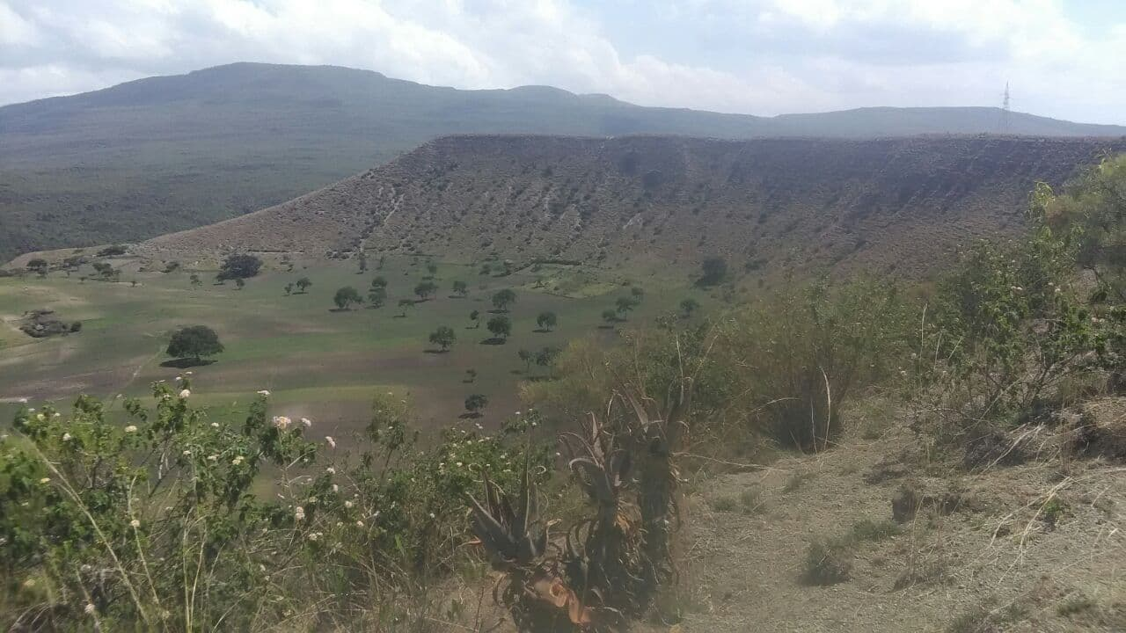

Abstract
The study area is located in central part of main Ethiopia rift in around Hawassa. The goal of this works is to map the igneouse rock succession of the study area. Orentesion of igneous rock, type and classify that rock in their character .we use three method in our study area, those are. Office work ;.during office works we trained how to read toposheet, how to locate our self ,how to use geological equipment and the general over view of the area .In the field work we identify the lithology of the area,structure ,texture ,color ,hardiness of igneous rock and taking sample by using sample bag and also we take elevation difference ,temperature and whole character of the area . During post field work we make geological map, geological cross section, stereographic columns and writing reports about the area, also identify the igneous rock units.

Acknowledgements
we would like to thank Hawassa University, College of natural and computational sciences for their supply of transportation and finance, department of geology for arranging this field work, providing the materials which are necessary in the study. Head of department Mr. Wegene , Mr. Yafet-Our adviser, gave us the literatures and advised us how to perform the study efficiently, Mr. Tamene , Mr.Tolosa and Ms Tizta for their help in numerous way so that we have great thanks to all those colleagues for their great help. we would like to great thank the peoples around the study area the showed us road when we lost the direction and for their security and also car drivers.

Table of contents
……
Table of Contents
Abstract
1. Introduction 1
1.1 Background 1
1.2. Location and accessibility 1
1.3 Geomorphology and Physiography 2
2
1.3.1. Climate 2
1.3.2. Drainage pattern 3
1.4. Objectives 3
1.4.1 General Objectives 3
1.4.2. Specific Objectives 3
1.5. Methods and Materials 4
Methodology 4
2.2 Volcanism and Volcanic Products in the Main Ethiopian Rift (MER) 7
2.2.1.1 Volcanic deposits 7
2.2.1.2 Non-volcanic rock 8
2.2.2. The evolution of the Central and Northern MER 9
2.3 Tectonics of the MER 11
3. Geology of the Hawassa Area 11
16
4.1. Economic importance of volcanic products 19
4.2. Geothermal energy and recreational purposes 20
4.2.1 Geothermal energy 20
4.2.2. Recreational purposes 21
4.3. Volcanic and seismic hazards 21
4.3.1. Seismic hazards 21
4.3.2. Exogenous hazards 22
4.3.3. Erosion-related Hazards 22
5. Conclusion and recommendation 23
5.1.Conclusion 23
23
5.2.Recommendation 23
References 24

….

List of Figures and Table

Figure 1 location map of study area 2
Figure 2 the three sidments of MER 10
Figure 3 The pumice unit of the study area 13
Figure 4 The scoria unit of the study area 14
Figure 5 The Rhyolite unit of the study area 15
Figure 6 The unit of ignimbrite of the study area 16
Figure 7 Colomunar joints of the Rhylite of the study area 17
Figure 8 Sill intrusion 18

1. Introduction

1.1 Background
The Main Ethiopian Rift System is part of the great East African Rift system that contains the Northern, Central and the southern segments. Main Ethiopian Rift is a roughly NE-SW trending sector of the East African Rift system that includes a series of rift segments extending from the Afar Triple Junction which is the intersection point of three east African rift systems:-Red sea rift, Gulf of Aden and MER. The MER is characterized by active extensional tectonics accommodating a significant displacement relative movement between the African plates and Somalian plates. Active extension in the area is manifested by topography, volcanism and seismic activity. This segment is characterized by having different geological structures like faults, folds and joints, and volcanic landforms including fault ridges, cinder cones, $:$volcanic domes, and shield volcano and so on. The field work is conducted in the central segment parts of the Main Ethiopian Rift system around Hawassa. Since the area is characterized by having good rock exposures, quarry site, hill site, river cuts), different lithological units (Tuff, Ignimbrite, Basalts, Scoria, Rhyolite, pumice), geological structures (faults, joints and folds) and some volcanic land forms like fault ridges, cinder cones, volcanic domes, shield volcano, strato volcano, crater and caldera.

1.2. Location and accessibility
The study area is found in the central part of main Ethiopia rift. The Geographical location of this area is between a longitude of 434000mE-448000mE and latitude of 772000mN-790000mN.
The study area is very accessible. In addition to this, the asphalt road crosses the study area. Along the study area, trails are enough and comfortable for mapping. Generally, the study area is highly accessible.
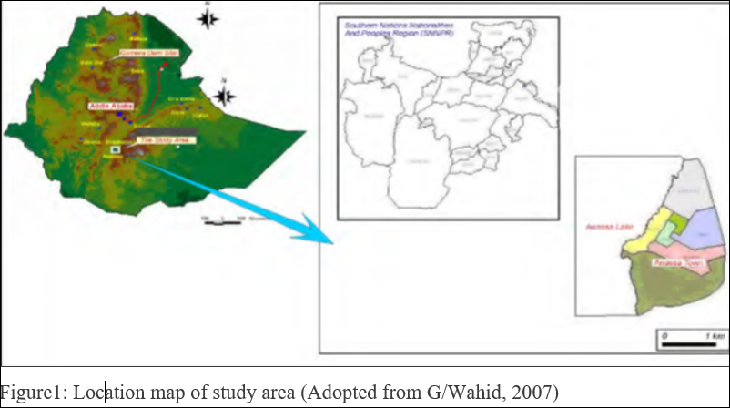
Figure 1 location map of study area

1.3 Geomorphology and Physiography

The dynamic geomorphologic map is focused on an explanation of the genesis of each landscape form and the study of geological and climatological predisposition and the resulting geomorphological position.

The studied area is located in the central part of the MER. The enormous volcanic and tectonic activities that took place in the Quaternary period (Boccaletti et al., 1998) created distinct physiographic groups in the study area identified as the mountain, ridges and cliff blocks bounding the caldera floor. The caldera rim and the fault scarps are transitional land between ridges and caldera floor characterized by a gentle slope with elevation ranging from 1,700 to 1,860 m a.s.l. The caldera floor is characterized by having numerous scoria cones those are elliptical in geometry with NNE-SSW major axis direction. The highest point of the map is the Chabi (syn. Chebi) peak, 2,314 m a.s.l., the top

1.3.1. Climate
The study area is characterized by having arid and semi-arid climate condition with hot temperature at day and moderate to cool temperature at night.The area is controlled by sparse vegetation like shrubs, scrubs and bush, and some of the study area is also controlled crop cultivation especially sugarcane and maize.

1.3.2. Drainage pattern
The study area have drainage pattern mainly called dendritic drainage pattern which feeds the main rivers and streams.

1.4. Objectives

1.4.1 General Objectives
The general objective of the field work is to map the igneous terrain in Hawassa and it is surrounding area, to produce geological map.

1.4.2. Specific Objectives
The specific objectives of the field work are to: -.
- Identify the different types of geological structures that are found in the study area.
- Identify and map the various lithologies of volcanic rock units
- Distinguish the different types of minerals found in mafic and felsic volcanic rock
- Understand modes of formation of volcanic rock
- Know the economic importance of the volcanic rock
- To produce geological map
- Writing report and make presentation.

1.5. Methods and Materials

Methodology
The method that we have used to conduct the field work had three phases. These are Pre fieldwork, (phase I), during fieldwork (II) and post field work. (III)

Pre fieldwork (phase I)
In this phase we collect information about the study area from familiar persons. The temperature the climate, local peopl’straditions, what and how to study in the field are determined in this phase. In addition, instructors determined the scale and quality of maps, prepared topography map and fixed the probable schedule.

During fieldwork (phase II)
This phase is in our study area we learned different volcanic rocks and different structures. In the first day, we performed our road geology. During this work, we investigated all rock units found in the area. We used topography maps of the study area.
After we finished our road geology we selected best three traverses which can join us with good exposures .in those traverse, we have observed different rock exposures and various geological structures. Varies type of methods are used like, reading of GPS in different stations, compass for navigation and sample bag for collecting rock samples etc.
We have followed various methodologies to reach our aims these are;
- Selecting the best traverse which can connect us with different lithologic unit and different geological structures,
- Describing different rock out crops with their fresh and weathered color,
- Marking of contacts where there is a change in lithology in our topographic map,
- Taking GPS reading to locate our station on topographic map,
- Collecting samples which can represent the exposure and further used for laboratory study
- Observing volcanic land forms and their tectonic history.

Post fieldwork (phase III)
Finishing phase II, we arranged a time to gather all geological information that is recorded during field work in order to produce significant geological map of the study area. We read many books as well as scientific papers for reference. We used scientific paper of regional geology in order to know the regional overview, tectonic history and general stratigraphic succession of the rift system. Finally we conducted the geological report of igneous mapping terrain in Ethiopia rift valley around Hawassa.
Material
It is clear that geological fieldwork requires different instruments or materials for verity of purpose. Geologist use different material to conduct the field work. Here are some of those equipments
- Geographic positioning system(GPS); used for finding positions and measuring the amount of elevation in order to know the geological structure formed in the area and shows the exact easting and northing positions where we are.
- Topographic map; is used to show geological features of the study area using contour lines.
- Geological hammer; is a a very important tool for a geologists to cut rock sample
- Compass; is used for determining direction and orientation of different geological structures (joints, folds, and faults) and bedding nature of the rock (dip direction, dip amount, and strike).
- Mobile camera; we used for taking photos of different features
- Sample bag; is used to collect and holding the samples after they are braked and labeled.
- Plaster and marker; is used for labeling samples before we put into the sample bag.
.

2. Geological and Tectonic Setting
2.1. Regional Background
The East African Rift system (EARS) is a region of continental breakup marking the incipient plate boundary between Nubia and Somalia plates from Djibouti to Mozambique. Within the EARS the Main Ethiopian Rift represents the link region between the Afar triple junction and the Kenya Rift regions where extensional deformation nucleated as early as late Oligocene-early Miocene times[e.g., Morley et al., 1992; Ghebreab, 1998; Ebinger et al.,2000; Bellahsen et al., 2003]. By contrast, deformation in the intervening region started apparently much later giving rise to what is currently known as Main Ethiopian Rift [e.g.WoldeGabriel et al., 1990; Ebinger et al., 1993; Chernet et al., 1998]. This EARS’ sector has a complex structural pattern consisting of rift segments with time-space tectonic evolutions that are apparently different one from each other. In this study we use structural (fault kinematics, remote sensing and aerial photo analysis), petrological, geochronological data and analogue modeling studies to attempter conciling the evolution of the distinct Main Ethiopian Rift segments into a coherent scenario accounting for the propagation of the EARS between the Afar and the Kenya Rifts.
Hawassa Caldera
Hawassa caldera is filled by thick accumulations of unconsolidated sediments and pyroclastic. Such a setting has the potential to also amplify seismic effects during earthquakes in the wider surroundings. For this reason, higher buildings should preferably be constructed in the eastern part of Hawassa town on the basaltic ridge. The western part of the Hawassa Caldera (west of Lake Hawassa) is strongly affected by spreading of the rift floor and formation of ground cracks (fissures). Unexpected opening of these cracks causes loss of property and occasionally also loss of life. Young silicic pyroclastic rocks (pumice) contain high amounts of leachable fluorine. Groundwater contaminated with fluorine used as drinking water causes fluorosis of teeth and bones. Technology for removing fluorine from the water sources should be applied to protect public health.
Corbetti Caldera
The corbetti caldera which is found North West of Hawassa Lake is a nested caldera within Hawassa caldera. The corbetti caldera has two volcanic centers, Urji and Chebi. The Urji centre is a source for the formation of pumice in the vicinity and Chebbi is a centre for the formation of obsidian which covers the Chebbi Mountain.The closed basin of the nested Hawassa corbetti caldera complex is a giant elliptical depression 30-40 kms wide. There are a number of rift system faults with north and northeast trend along which the length of Lake Hawassa is oriented. These faults are expansion (normal faults) forming step faults. These are mainly dominant to the south and southwest of the lake. The volcanic collapse structure (caldera) forms nearly circular structure around Lake Hawassa basin. Corbetti calderais situated in the north-western part of the ancestor Hawassa Caldera.

2.2 Volcanism and Volcanic Products in the Main Ethiopian Rift (MER)
2.2.1. Volcanic and Non-volcanic products

2.2.1.1Volcanic deposits

Nazret Group ignimbrites: (only in the geological cross-section) do not crop out in the area of the Hawassa basin but cover large areas in the surrounding region namely in the rift scarps and on the rift shoulders. Welded and non-welded ignimbrites dominate in this unit, with intercalations of coignimbrite fall deposits and minor lavas. The chemical composition of the rocks representing this group corresponds to alkaline rhyolites and trachytes. The age of the Nazret group has been determined as between 9.5 and 3 Ma (Kazmin and Seife 1978). The thickness of the Nazret Group reaches several hundred meters (400 m around Aluto Volcano: Abebe 1984; EIGS-ELC 1985; 600 m on the eastern margin of the rift WoldeGabriel et al. 1990; 500 m in the rift escarpments Basalfew 2012).

Hawassa rhyolitic ignimbrites were produced by voluminous eruptions of a rhyolitic magma from the Hawassa Caldera. These ignimbrites are the oldest rocks exposed in the area of the Hawassa basin. The thickness of this unit remains unclear due to the lack of borehole data and difficult distinction of the overlying Corbetti ignimbrites. This unit comprises various alternating facies (welded, non-welded) of rhyolitic ignimbrites and associated fall deposits. Crystaloclasts of quartz and feldspars can be identified enclosed in a groundmass of deformed glass shards and frequent fiamme. On the contrary to the Nazreth Group, ignimbrites of the Dino Formation can be linked to individual source vents. Apart of the Hawassa Caldera, Ziway Caldera and most likely also Shalla belong to the Dino Formation. The ignimbrite of the Hawassa Caldera has been dated using the K-Ar method (JICA 2012) to 1.28 Ma on the sample taken 3 km south of the mapped area. This age corresponds well to the ignimbrites surrounding Lake Shalla (1.35 Ma, K-Ar: JICA 2012). Ages 1.1–1.85 Ma (K-Ar) are also given by Wolde/Gabriel et al. (1999).
Basaltic lapilli-stone (tuff-cone) form the Tabor volcanic cone within the town of Hawassa (RP HSRVR005), unnamed volcanic crater (RP HSRVR179) on the southern skirt of Hawassa town and an unnamed hill representing an erosional remnant of a tuff cone (RP HSRVR180) to the west of the road from Hawassa to Shashemene. The extent of the lapilli-stones is limited to the size of tuff cones and their thickness to the height of these cones. The lapilli-stones are poorly-sorted clast supported and dominated by massive non-vesicular basaltic clasts with a prevailing grain-size of 1 cm, but larger clasts (up to 20 cm), often with xenolith in the core, may occur as well. These pyroclastic deposits were produced by phreatomagmatic (Surtseyan) eruptions in marshy or shallow-lake environments. Therefore these deposits are located on margins of the basaltic ridge and not on its top, where scoria cones occur. The tuff cone on the Hawasa-Shashemene road (RP HSRVR179) penetrates and overlays old obsidian from Chabi Volcano, suggesting the mafic volcanism of the Hawassa basaltic ridge might be of Middle Pleistocene age. A younger age of this sequence is not likely as Volcaniclastic the deposits are significantly altered and affected by erosion.
Basaltic scoria (scoria cones) can be found forming two small cones along the Hawasa bypass. The scoria is poorly sorted and clast supported, dominated by fragments of scoria predominantly 5–10 cm in diameter, frequently with large bombs. The bombs are flattened in the crater facies, whereas in the wall facies spindle shaped bombs can be found. The scoria cones are associated with basaltic lavas and were produced by Strombolian style eruptions. Similarly to the lapilli-stones, the extent of the scoria deposits does not exceed the size of the scoria cones and their thickness is equivalent to the height of the cones. The age is estimated as being Middle Pleistocene. No current fumarolic activity has been documented associated with the scoria cones.

2.2.1.2 Non-volcanic rock
Quaternary Sediments: Quaternary /lacustrine / Sediments are dominantly distributed with large stretches at the eastern and western side of the lake and they overly the ignimbrites. They consist of alternating fine and coarse sand beds. The size of the materials varies from silt to gravel size, with the dominant size being fine to medium-grained sand particles. These sediments/ volcano-lacustrine deposits mainly cover the floor of the depression, and are mostly of volcanic origin. The Quaternary units also comprise alluvium and flood plain deposits. They are distributed along the river channel, river terraces and their banks’. They constitute fine to medium sand and sometimes gravel with clay matrix. The existing built-up area of the town and its proposed future expansion zone are almost entirely covered by these lacustrine sediments (G/Wahid ,2007).
Colluvial sediments do not form voluminous deposits in the area of Hawassa basin even though; steep slopes are frequent on caldera scarps. Predominant sandy material and gully erosion on the scarp do not create favourable conditions for colluvial sediments. The sediments are related to the rare occurrences of accumulation parts of landslides. The deposits are formed by blocks of weathered ignimbrites and pyroclastics.
Alluvial sediments are bounded with recent alluvial fans. The creation of an alluvial fan is related to erosion of material in the slope during rainfalls, transported by sheet-flows or density currents. Alluvial fans are generally formed in the areas with abrupt decrease of due to a deceleration of flow at lower gradients. The alluvial fans are located in the mouths of stream-flow valleys or erosional valleys and gullies. In the Hawasa basin area they are located on the foothill of the western escarpment (north of Muleti, west of Lake Hawasa). Alluvial sediments are formed by resedimented soil and fine to medium grained sands with a high portion of weathered volcanic and volcaniclastics. The angular clasts of pumice are common within the sandy sediments.
Fluvial sediments are very rare on the Hawassa basin because of a lack of fluvial systems in the area. Limited occurrence of fluvial sediments is related to a drain channel (Tikur Woha) connecting Lake.

2.2.2. The evolution of the Central and Northern MER
The Northern main Ethiopian rift system
The Northern MER is considered to extend from the true Afar depression up to the Lake Koka region, following the middle course of the Awash River valley. The main boundary faults in this region formed about 10-11 Ma ago (Kazmin et al., 1980; Mohr, 1983). The Northern MER is characterized by two distinct fault sets. These are NE–SW trending border faults on the boundaries of the rift, and a set of closely spaced NNE–SSW-trending faults (Hutchison et al., 2015).

The central main Ethiopian rift system
The Central MER contains most of the Lakes Region, up to the Lake Awassa area. In the Central MER, the faults were formed at 6–8 Ma (WoldeGabriel et al., 1990; Bonini et al., 2005); while the Wonji faults initiated 2 Ma (Corti, 2009). The main boundary faults are well developed at the age of late Miocene– Pliocene post-6–7 Ma (Bonini et al., 2005). In the CMER, the border faults are still seismically active (Hutchison et al., 2015) and much of the active tectonic deformation occurs in the magmatic segments through NNE–SSW Wonji faults (Keir et al., 2006). These could be related to the hydrothermal system. The central main Ethiopian rift has many different formations, corbetti caldera, and Hawassa caldera and so on.
The Southern main Ethiopian rift system
The Southern MER extends south of Lake Hawassa into the ~300-km-wide system of basins and ranges. The first extensional structures in Southern MER developed as N-S trending Kenya Rift related structures at about 20–21 Ma and lasted up to 11 Ma. According to Molin and Corti (2015), in the southern MER, a few major boundary faults accommodate the largest part of recent and active deformation.
Most recent silicic products in the northern Ethiopian rift have erupted from central volcanoes with large summit calderas, such as Gedemsa, Kone and Fantale and forming very thick pyroclastic deposits, thought to have been partially produced from fissures. These volcanic products are about 5 Ma and are known as the Nazret group (Electroconsult, 2015). Quaternary volcanism in the northern Ethiopian rift consists of dominant peralkaline rhyolites, minor trachytes, and transitional basalts.

Figure 2 the three sidments of MER

2.3 Tectonics of the MER
The Ethiopian Rift system is located in the eastern branch of EARS, and started to develop during Miocene time (Cort, 2009). This rift is basically a very large graben formed by tensional movements as a result of drifting of the Nubian and Somalian plates with a concomitant domal uplift. It extends about 1000 km in a NE-SW to N-S direction from Afar southwards to the Turkana Depression (Corti, 2009; Pürschel et al., 2013; Samson Tesfaye et al., 2003 as cited G/Wold, 2011). The MER extends some 500km NNE from just south of latitude 6 degrees N near Lake Chemo to latitude 9 degrees N where it meets the complex afar triple junction. The MER separates the Nubian and the Somalian plate, its trough is between 35 and 85 km wide and bounded by large normal boundary faults, which developed during the Miocene. The major escarpment between the rift floor and the flanking southern and northern Ethiopian plateaus is built by steep NE striking normal boundary faults and the relative displacement reaches overall differences in height of up to 2000m (Corti, 2008 as cited G/Wold, 2011). This all about MERS, but we are mainly concentrated in Hawassa caldera.

3. Geology of the Hawassa Area
The study area is located in central part of MER and specially called Hawassa caldera which is of corbetti caldera and other volcanic landforms (domes, cones, and ridges). The exact location of the study area can be read from GPS as E: 434000m-448000mand N: 772000m-790000m. The areal coverage of the study area is 252km². Every units of lithology, landforms and other diagnostic features of the place was formed after the rift so we can say that post rift. For example corbetti caldera is formed after Hawassa caldera and the sub calderas such as chabi and urji with in the corbetti caldera are formed after corbetti caldera (caldera within caldera). From the knowledge of super principles-caldera formed within caldera is younger than the one which surrendered it. The area has variety of vegetation distribution pattern as well as drainage. The parts of the study area which covered by pumice unit is almost bare and at some places there is very small and sparsely populated plants, conversely the place where covered by welded tuff (around Tabor Mountain) and highly weathered rhyolite (Boricha-locality name) has very giant and dense population of plants. Note-surely the exact rock cannot have any types of plants at all so that those vegetation that we have observed in the study area are grew at the weathered parts of rocks/top most parts which exposed to weathering and incase changed into soil which is suitable for plant growth.

3.1. Local Geology
Igneous rocks are a type of rock that formed from molten rock that has cooled and solidified on the surface or beneath the surface. The molten rock (called magma) can then flow upward or even be erupted from a volcano onto the Earth's surface. When magma cools slowly, usually at depths of thousands of feet, crystals grow from the molten liquid, and a coarse-grained rock forms. When magma cools rapidly, usually at or near the Earth's surface, the crystals are extremely small, and a fine grained rock results. A wide variety of rocks are formed by different cooling rates and different chemical compositions of the original magma. However in our study area we have seen the extrusive or volcanic rock that formed when magma cooled on the earth surface. There are different types of rock exposed in study area and have the following description.
The volcanic rocks of Hawassa area can be classified into mafic and felsic based on their mineralogical composition. The felsic rock units have light in color and these are resistant to weathering and erosion than mafic rock units. This is due to felsic rocks are silica tetrahedral saturation. The mafic rock units are black in color and dominantly composed of mafic minerals. Generally, the main types of rock units that are found in the study area are: Scoria, Ignimbrite, Basalt, Rhyolite, pumice, obsidian and tuff

The various lithological unit that have observed and discussed below

Pumice unit:This unit of igneous rock in the study area is exposed by quarry site and located in the north eastern part of Lake Hawassa around cheleleka. It is extrusive igneous rock with vesicular texture. This vesicular texture is formed from combination of rapid cooling and high gas content. White in color, very light in density due to the presence of lots of gas bubbles pockets, and often floats when placed in the water. It is also a felsic volcanic rock .The observable pumice in our study area is exposed by quarries while others are covered by vegetation. Pumice deposit is the volcanic product of explosive style of eruptions
Like scoria pumice has vesicular texture but it different from scoria by having higher concentration of trapped bubbles and air filled vesicles, those vesicles make the rock to float on the water.
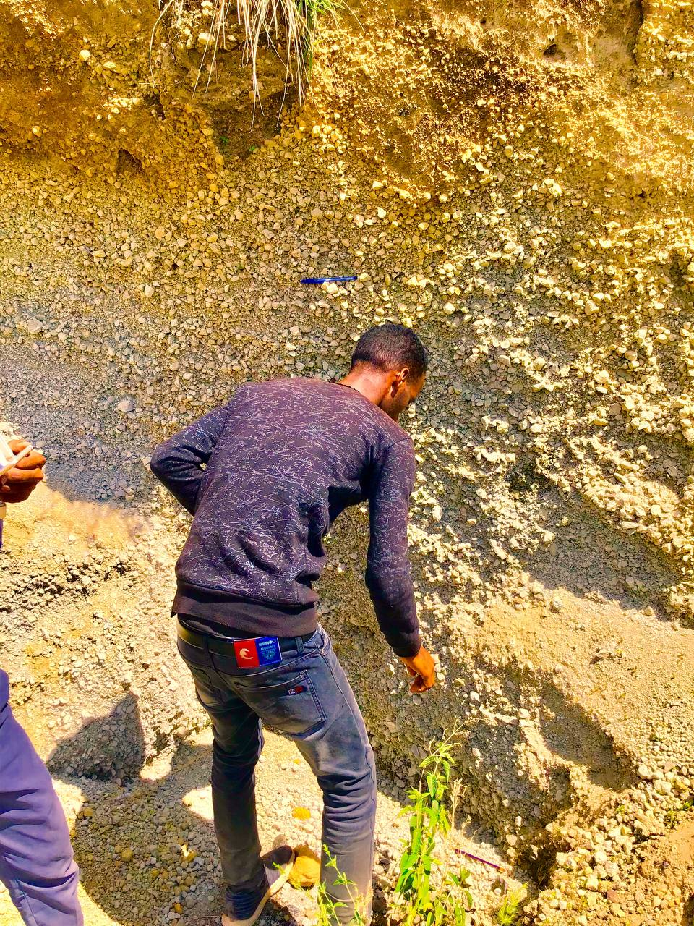
Figure 3 the pumice unit of the study area

Scoria unit:Scoria is mafic or basic volcanic rock that has dark brown and reddish color around study area. The dark brown color of scoria is un weathered or fresh one occurred around quarry site on cheffe ridge. Scoria is igneous rock with abundant round bubbles like cavities known as Vesicles. It forms from basaltic magma and usually form domeshaped extrusive on the earth surface. Due to iron rich the color of scoria changed to red. It is fine grained and vesicular texture.
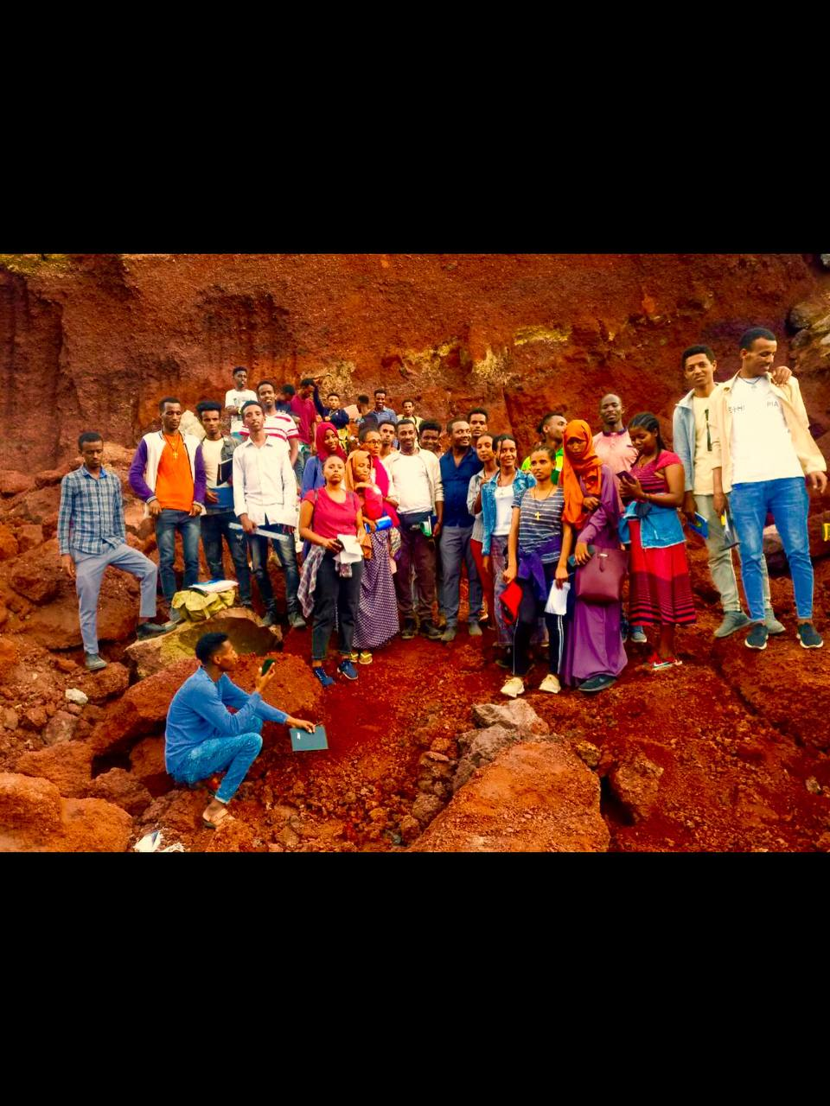
Figure 4 the scoria unit of the study area

Rhyolite unit:Rhyolites are extrusive igneous rock which is formed when magma erupted reach earth’s surface and cools or solidifies rapidly. They are characterized by their aphanites texture and light color. These are white and black bands (Whites are feldspars and black bands are biotitic). These structures are due to cooling of lava and shows different sequence of eruptions. It is compositionally felsic composed of mineral quartz and feldspar. As a result, they are characterized by their higher silica content. Due to this high silica content, Rhyolite lava is very viscous and flows slowly.The distinctive feature of this rock is a flow banding that formed during the cooling of lava and shows different sequence of eruption and the viscosity of lava is high. It contains mostly light colored quartz and feldspar minerals. Rhyolite form volcanic land form called lava dome.

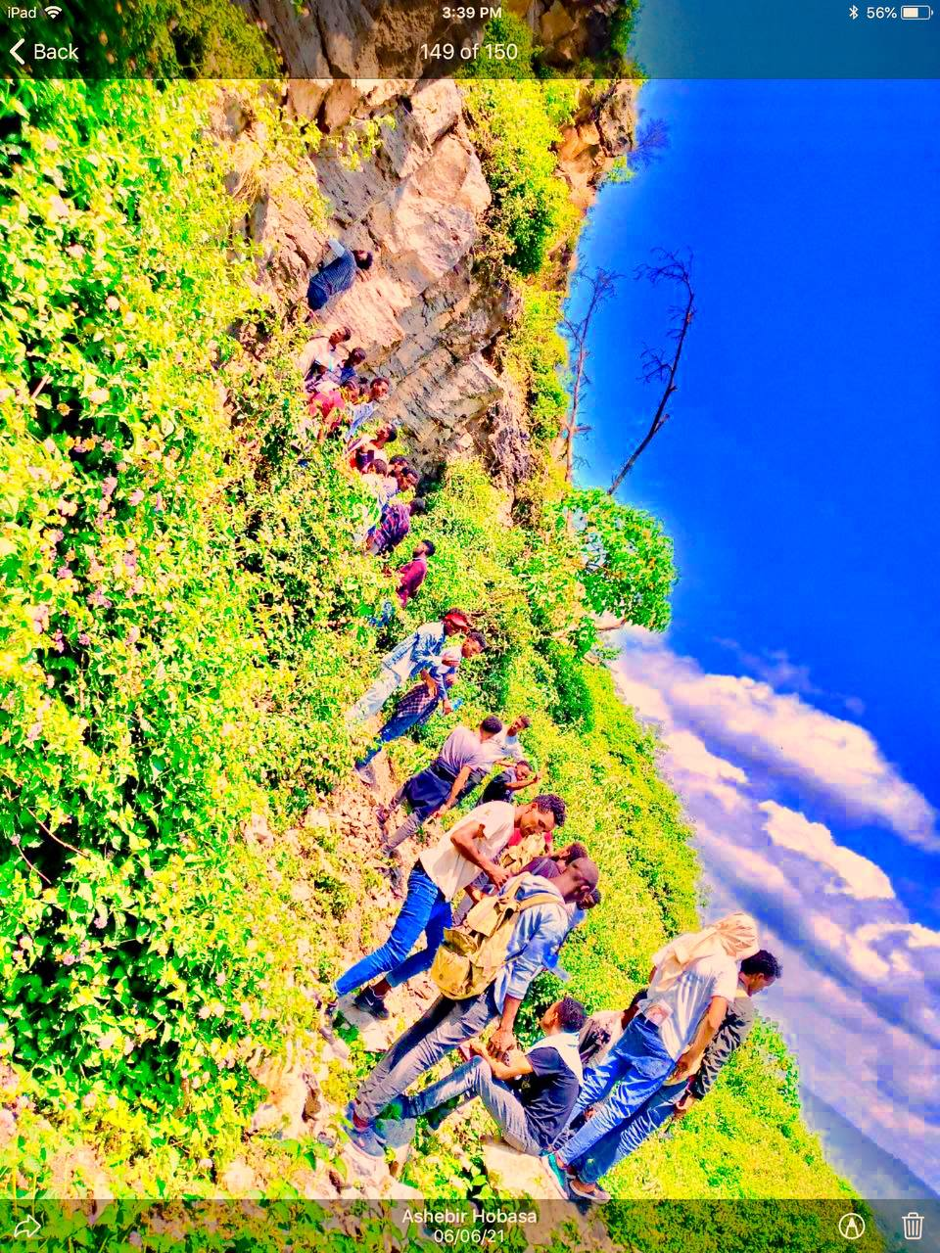
Figure 5 the Rhyolite unit of the study area

Obsidian unit:Obsidian is a felsic, extrusive igneous rock with a glassy texture Formed from very rapid cooling of magma. Due to rapid cooling of ions obsidian are amorphous, meaning they have no structure. Its color is shiny black. Its structure is massive, smooth and with sharp edges. It is acidic igneous rock. Obsidian is formed by rapid cooling of magma, so mineral grains are very fine to identify the type of the mineral. Obsidian is characterized by massive structure.It is sparsely scattered in the area. This rock unit is unmapeble and is found randomly across the study area.

Ignimbrite unit:It is extrusive igneous rock which has light grey to dark grey and compositionally felsic. This rock formed by well-developed tuff materials. Its fresh is light grey in c olor; dark grey is its weathered colors, hard and denser. Ignimbrite is either welded or un welded. Welded ignimbrite is formed due to high heat.
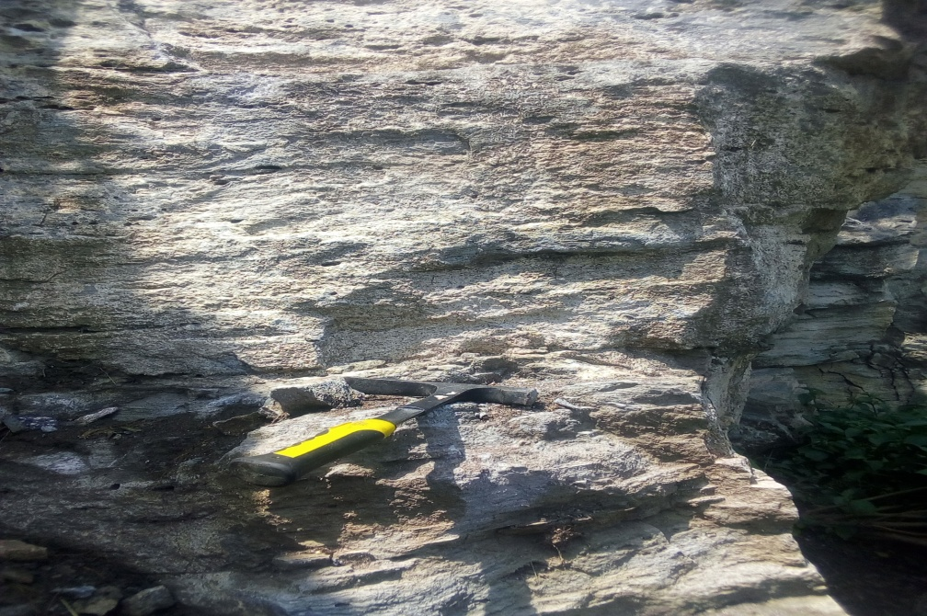
Figure 6 the unit of ignimbrite of the study area

3.2. Tectonic Structures
Joint:This is opening in the rock unit without relative movement of one another so that it is impossible to differentiate hanging and foot wall in the joint. One of the types of joint which is columnar dominated in the rhyolite rock unit in the study area, which is due to its high rate of cooling. Additionally, in welded tuff which is located in eastern part of the lake Hawassa (Tabor).
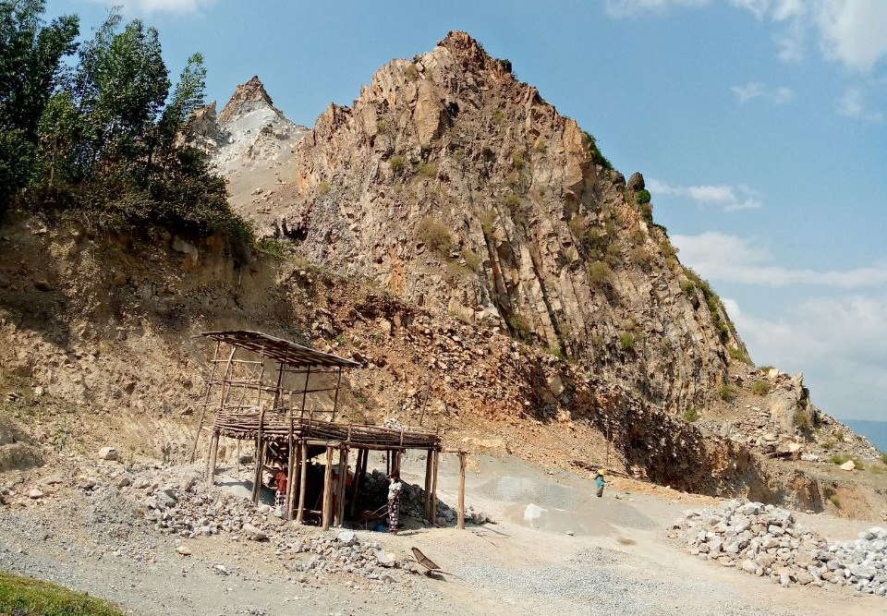
Figure 7 Colomunar joints of the Rhylite of the study area

Sill:This is the horizontal intrusion of one rock type in the other rock unit which is different in composition. This structure found on both welded tuff unit and scoria in the study area and its composition is completely different from the one in which it intruded. It is exposed by road cut at the base of mountain tabor and by quarry in the chafe. The thickness of this intrusion is nearly one meter but this thickness is not the same throughout.
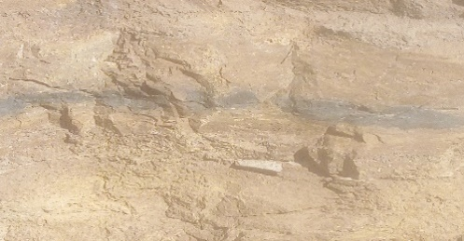
Figure 8 Sill intrusion

4. Economicand Environmental Impacts

4.1. Economic importance of volcanic products
There are numerous importance of igneous rocks, some of them illustrated below (here, our explanation includes the usage of lithology for local peoples and its general usage to mean that people around that area may not use for certain purpose even though the lithology have many usages

Basalt: It is used for variety of purpose. It is most commonly crushed for use as an aggregate in construction projects. Crushed basalt is used for road base, concrete aggregate, asphalt pavement aggregate, rail road. Basalt is also cut into dimension stone and used for construction of house.

Rhyolite:Rhyollite rock unit is an important rock unit for construction purpose. It has variety of use in construction industry. It used as abrasive and diverse ornament. Rhyolite is also used as a decorative rock in landscaping and in some jewelry. It is also used for construction as dimension stone and as a gemstone.
Scoria:The most common use of scoria is in decorative land scaping. It is also in construction of athletic track, to decrease mud property of rain rainy season.
It is used in light and full of air pocket; this makes it very useful in aggregate in cement which result in material that as strong as concrete especially for floor, roof and slab. It’s used for gravel road construction and block production on building purposes.
Ignimbrite:Ignimbrite is used for construction and includes, building houses or walls, construction aggregate.
Ignimbrite is also used for architecture

Pumice:Pumice has lots of usage and importance. It is used for decorative and landscaping purpose.
It uses for construction purpose and also it is used for personal care as heels during foot bath or feet treatments.
It is less expensive than hand-cut rock, so it is used additive to make light weight cement.
It is used for house hold cleans, pumice rocks are ground in to powdered form and then added to cleaning products to enhance cleaning and help create polished appearance.
It is used its powdered form and as an ingredient in cleaning products, pumice provides cleaners with the benefits of abrasion without scratching surface.
Welded Tuff:It is commonly used for construction where it was available, for many buildings and bridges. For example, the whole port of the island of Ventotene (still in use), was carved out from tuff. The Serbian Wall, built to defend the city of Rome in the 4th century BC, is also built almost entirely from tuff. The Romans also cut tuff into small rectangular stones. It is mainly used for agricultural and decorative purposes. It is also used for construction like huts and some modern houses.

4.2. Geothermal energy and recreational purposes

4.2.1 Geothermal energy
There are three geothermal areas in the central main Ethiopian rift system:-Aluto-langano, Tulo moye and corbetti geothermal area, but our concentration is more on the corbetti geothermal area.
Corbetti Geothermal Area
This is part of the southern lakes district basin in the CMER, the corbetti geothermal area is named after the prominent structure in the area, the corbetti caldera. Other important structures include volcanic belt hosting Mt.Urji and Mt.Chebi. It is silica(high silica) volcanos with in a 12km wide caldera that contains wide spread manifestations such as fumaroles and steam bents.

4.2.2. Recreational purposes
Wondo genet Hot spring:This is the place where visited by tourist in current time. It has many amazing land features and full of plants which are attractive to sight. The air is very fresh and it make any one to adore. This best place present in the Hawassa caldera.

Lake Hawassa:Lake hawassa used as recreational place for both foreign and domestic tourists. It is also more important for fish market. Which is located in the western part of the study area and it is called as caldera lake.
.

4.3. Volcanic and seismic hazards

4.3.1. Seismic hazards
There are three reported earthquakes with epicentres fitting to the area of the Hawassa subsheet. The earthquake from September 6th 1944 is likely to have taken place in the south-eastern corner of the sub sheet, but the location and even the occurrence of this event is very uncertain. There was, however, a strong earthquake (magnitude 6.3) on July 14th 1960 most likely in the area of the south-western slopes of the Chabi Volcano (Gouin 1979). The USGS earthquake catalogue has been available since 1973, this catalogue contains another earthquake from January 20th 1995 which most likely occurred within the edifice of the Chabi Volcano. Due to the poor coverage of seismic stations in the area, not even the latest event is localized with a precision exceeding ± 50 km. The older earthquakes are localized with a precision of ± 200 km.
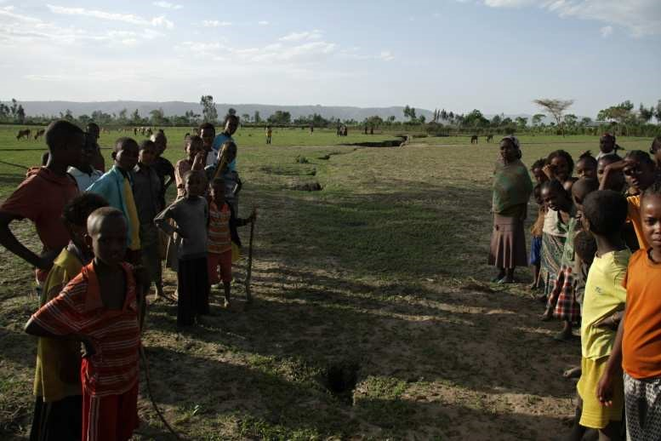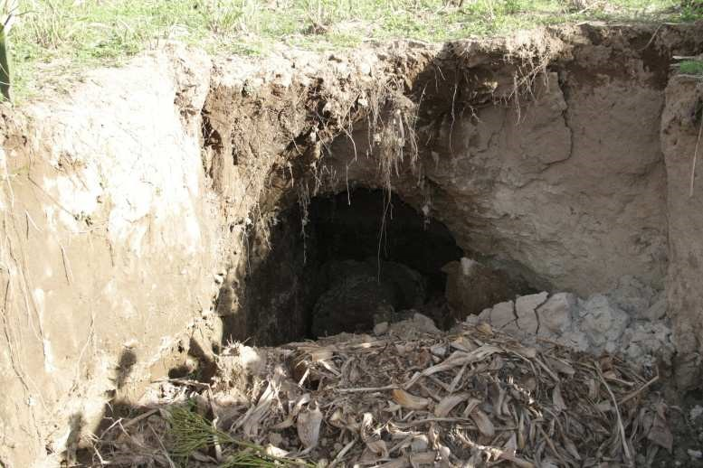

Figure 9 N-S oriented fissure system in the Jara Figure 10. Subsurface erosion pipe associated with Dado area. Photo J. Malík. Ground fissures in the western part of Hawasa Caldera. Photo J. Malík.

4.3.2. Exogenous hazards
The area of the Hawassa sub sheet is characterized by expressive escarpments in the western part and a flat area representing the main rift floor. Rapid expansion of settlements and the associated needs for agriculture and other human activities have changed the land use abruptly over the last tens of years. By consequence, exogenous geological hazards are becoming an ever more serious problem to the people living in the area. The area is strongly affected by various types of erosion related to loss of land and creation of fissures on the surface of the rift floor.

4.3.3. Erosion-related Hazards
Soil erosion is a major cause of land devastation in the Hawassa area. Water is the most important agent of erosion, however wind erosion is sometimes observed. Erosion features are a common feature of the landscape in Southern Ethiopia (e.g. Billi and Dramis 2003). As a natural exogenous process of the landscape it is frequently accelerated by agricultural and related human activities and deforestation and the escarpments to the west of Lake Hawasa are strongly affected by this geological hazard. Weakly compacted alluvial and lacustrine deposits, resedimented volcaniclastics, and other pyroclastic materials, which are easily workable, cover the Hawasa area, the soils can be detached easily by agricultural and livestock activities.

5. Conclusion and recommendation

5.1.Conclusion

The Great East African Rift System which formed by the relative movement of three plates named Somalian, Nubian and Arabian plate. It divided in to three branches making its point of junction at Afar (Afar triple junction):-Red Sea, Gulf of Aden and MERS. The MERS itself divided into three based on structural arrangement which are Northern part of MERS, Central part of MERS and Southern part of MERS. Our study area mainly concentrated in central part of MERSspecially called Hawassa caldera. In the study area, there are different lithology which are post to the caldera such as pumice, scoria, basalt, ignimbrite, rhyolite and welded tuff. And the place is dominated by volcanic land forms, caldera, ridge, and crater. Finally, the economic importance generally describes of varies igneous rocks are discussed.

5.2.Recommendation
The Main Ethiopian Rift is one of the most important and potential area economically in Ethiopia. Government and any other sector which may work in this area have to give attention, for this natural area. The study area is full source of power,income and recreational purpose even though haven’t been worked on as much as possible so that we recommend that better if government pinpoint the place, additional researches must be conducted to better exploit the natural resources including the volcanic rocks, the geothermal resource, and the groundwater potential and to protect the local people of the area from geological hazards such as earthquake and volcanism as the area is active site of volcano-tectonic activity. Since the rift is widening continuously, after millions of years it may change in to sea. Geothermal resource is being given a better global attention recently.

References
Agostini, M. Bonini, G. Corti, F. Sani and F. Mazzarini (2011).Fault architecture in the Main Ethiopian Rift and comparison with experimental models: Implications for rift evolution and Nubia–Somalia kinematics. Earth and Planetary Science Letters 301: 479–492.
Bigazzi, B., Bonadona, F.P., di Paola, G.M., A., (1993). K-Ar and fission track ages of the last volcano tectonic phase in the Ethiopian rift valley (Tulu Moye area). In: geology and mineral resources of Somalia and surrounding region.
Boccaletti, M., Bonini, M., Mazzuoli, R., Abebi, B., Piccardi, L., Tortorici, L., (1998). Quaternary Oblique extensional tectonics in the Ethiopian rift (Horn of Africa.Tectono-physics 287, 97-116.
Boccaletti, M., Getaneh, A., Tortorici, L., (1992). The main Ethiopian rift: an example of oblique rifting. AnnalesTectonicae 6, 20-25.
Bonini M., Corti G., Innocenti F., Monetti P., Mazzarini F., Abebe T., (2004).
Geological map of the Nazret-Dera region. 1:50,000 scale, Italy.Danielli, G., 1943.
Journal of African Earth Sciences 48(2007):115-124.Boccaletti, M., and BekeleAbebe (1999). PlioQuaternary volcano tectonic activity in the northern sector of the Main Ethiopian. Boccaletti, M., Mazzuoli, R., Bonini, M., Trua, T., and BekeleAbebe (1999).Boccaletti, D Getaneh, A. Mazzuoli, R.tortorici, L, L, L. and Trua, T. (1992):
Mohr, P.A., (1983). Volcano tectonic aspects of the Ethiopian rift evolution. Bulletin Centre Recherché Elf Aquitaine Exploration Production. 7, 175-189
Mohr, P.A., (1987). Pattern of faulting on the Ethiopian rift valley.Tectonophysics 143, 169-179.
Morton, W.H., Rex, D.C., Mitchell, J.G., Mohr, P., (1979).
The Meyer, W., Pilger, A., Rosler, A., Stets, J., (1975). Tectonic evolution of the northern part of the main Ethiopian rift in southern Ethiopia.

